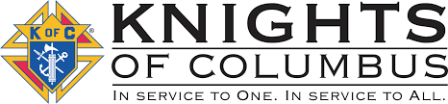

June 2024
A meeting is planned for Tuesday, June 4th at 8:00pm in Upsala. If anyone has questions or items for the agenda, please call Grand Knight Jeff Czech at 320-630-2753. Thank you.

Days of importance this month…
6/2 – The Most Holy Body and Blood of Christ
6/7 – The Most Sacred Heart of Jesus
6/8 – Immaculate Heart of Mary
6/24 – The Nativity of John the Baptist

Agenda Items…
-Float in the Bowlus and Upsala parades
-Idea: Knights presence at the first mass to be held in St. Edward’s church on June 29th at 5pm.

Thank you to everyone who helped with the ditch clean-up in May. Great job once again!

Thank you to all those who came to the Eucharistic procession in Little Falls. We had the privilege to escort our Lord to the Morrison/Todd county line. Approximately 1300 people turned out. What a great and honored experience to be present with our Lord.

St. Gregory the Great
Council #12604

Trivia Question… Which notable Saint falls into the Benedictines order of the Church?

THERE WILL BE NO MEETING IN THE MONTH OF JULY!

A unanimous ballet of nominations was casted at the May meeting to have our current officers remain as officers for the upcoming year. Election will occur at the June meeting.

Brother Knights…
As summer events begin to set in and travels increase, don’t forget to be still, pray and listen to the wonders of God. May you also pray for safety of the travelers that are processing with our Lord from the four directions of our nation and converging in Indiana in July; that it will be an enlightening experience for all. -Jeff

